April 8, 2014

*Progress Report*

Energy Efficiency in Las Vegas Homes

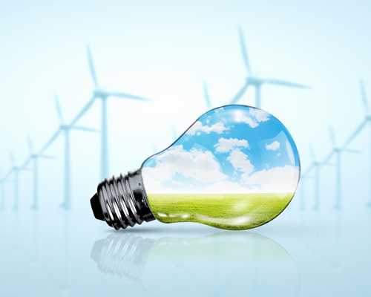

Jared Hayes

Edgar Solorio

Carlo Lopez-Telo

EGG 307 Dr. Kaseko

Problem

Las Vegas is home to over 2 million residents who experience some of the most dramatic weather conditions in the nation. This city continues to grow, not only as a tourist destination, but as a location for people to call home. The increase in population puts a strain on the energy needs of Las Vegas. We propose this project to find the most economical option for residents to reduce their energy consumption. Options such as purchasing solar panels to subsidize power needs, using efficient insulation, and switching over to more power efficient appliances can save the average resident money in the long run.

Objective and Motivation

The cost of electricity is a big part of a home’s monthly budget in Las Vegas. This is caused by constant use of air conditioning for half of the year, when temperatures can exceed 80° F. In the summer, temperatures can exceed 100° F, so air conditioning becomes essential for every home. The objective of this study is to compare different alternatives to lower the average annual power consumption of homes in Las Vegas; and then, choose the most cost efficient one. Even if the amount of energy used to cool homes cannot be reduced, lowering the energy consumption of other appliances can be a valuable alternative.

Potential Alternative Solutions

There are three possible alternative solutions we are focusing on in contrast to the do-nothing alternative.

*Insulation:*

One alternative to lower the cost of air conditioning needs is the installation of insulation around the home. The insulation layers would reduce the conduction of heat going into and out of the home to keep cold air in during summer and warm air in during the winter seasons. The major downsides to insulation include the higher risk of a house fire, toxic chemical release from the material catching fire, possible structural damage from certain materials such as expanding foam breaking through walls, and the possibility of reduced efficiency of the material over time.

*Install Power-Efficient Appliances*

A second alternative would involve replacing current home appliances with power efficient models; this includes items such as water heaters, refrigerators, and light bulbs. The benefits of power efficient appliances include reduced energy costs and usage of environmentally friendly appliances. The cons to energy efficient appliances are close to none except for the initial higher upfront cost.

*Installing Solar Panels:*

The third alternative we will focus on involves installing solar panels to a home to reduce the amount of home energy use. The downsides to solar panels include a high initial investment cost and the need to live in a region with high sunlight concentration and weather.

Data Requirements

For our project, we expect to obtain data on the population size of Las Vegas, as well as the energy usage of Las Vegas over the past few years. As an initial step, the following URL links were compiled to help us sift through the multiple alternatives.

* Population data of Las Vegas, and expected growth to calculate future cost of electricity.
* Average power consumption of Las Vegas homes today.
* Cost of energy during different months of the year from NVEnergy
* Manufacturer datasheets to find power consumption of appliances.
* Comparative studies of different insulation types.

Solar Panel info

<http://pveducation.org/pvcdrom/solar-cell-operation/efficiency>

<http://rredc.nrel.gov/solar/old_data/nsrdb/1961-1990/redbook/atlas/>

<http://pveducation.org/pvcdrom/properties-of-sunlight/average-solar-radiation>

<http://myelectrical.com/notes/entryid/225/photovoltaic-pv-electrical-calculations>

Insulation

<http://energy.gov/energysaver/articles/insulation>

<http://energy.gov/energysaver/articles/types-insulation>

<http://web.ornl.gov/~roofs/Zip/ZipHome.html>

Fenestration/ Windows, Doors

<http://www.nfrc.org/WindowRatings/The-Nfrc-Label.html>

<http://windows.lbl.gov/software/NFRC/NFRCSim5.2-2206-Chptr03.pdf>

Roofing

<http://windows.lbl.gov/software/NFRC/NFRCSim5.2-2206-Chptr03.pdf>

<http://web.ornl.gov/sci/roofs+walls/facts/CoolCalcEnergy.htm>

NV Energy Residential Rates

<https://www.nvenergy.com/brochures_arch/rate_schedules/np_res_rate.pdf>

Las Vegas Population

<http://suburbanstats.org/population/nevada/how-many-people-live-in-las-vegas>

Las Vegas Weather

<http://www.weather.com/weather/wxclimatology/daily/USNV0049>

Methodology of Evaluation

The methods of evaluation for each alternative will be listed below:

To evaluate the efficiency of a power savings appliance, we will do simple calculations to determine the actual power savings in terms of energy consumed vs. a non-power efficient appliance. From this, we will be able to determine the amount of money saved during different months of the year as well as during peak hours of a normal day cycle.

The MARR value we chose was 11.5 percent, which is the average return for the stock market from 1928 to 2013. We chose this value because it seems like the best long term investment alternative. Since it would be difficult to come up with an average home to compare the different appliances, insulation, and solar panel benefits, we are going to consider the viewpoint of someone moving into a new house. To find the best appliances we are going to find the most economical by comparing their initial value and yearly energy cost for a ten year period. Similarly, for insulation we are going to compare no insulation, average insulation, and high end insulation and see which is the most economical for a 10 year period. The analysis for solar panels will be different, since there is not much variation in performance between different panels. Instead of comparing different models, we are going to choose one and see how good of an investment it is at ten, twenty, and thirty years.

Project status

We are almost done collecting sources to perform the analysis. The biggest problem we have encountered is finding good sources on how to model the change in energy consumption after installing better insulation. Similarly we cannot find good online sources for the installation cost and performance of solar panels, since there is a lot of variation depending on the direction the roof faces. We still have to pick appliances for a base case to compare new appliances to, unless we decide to just compare new appliances and see which are the most economical.

**Remaining Tasks and Schedule**

Data collection is almost complete. The analysis of alternatives remains to be done. We plan to work on the schedule shown below for project completion.

April 12th - Finish analysis for appliance & insulation alternatives

April 19th - Finish analysis for solar panel alternatives and wrap up final report

May 6th   - Submit the Final report

Presentation and Discussion of Preliminary Results

We currently do not have any preliminary results to share at this point in our research and analysis. The final presentation will contain Excel spreadsheets of the present worth analysis between each of the alternatives along with accompanying graphs.